Citing an Essay, Story, or Poem in a Collection
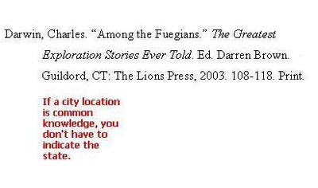
The example above refers to a story in a collection.

The citation method is the same, whether you are citing an essay, short story, or poem in an anthology or collection.
Notice the name order in the citation above. The author is given in last name, first name order. The editor (ed.) or compiler (comp.) is listed in first name, last name order.
You will put the available information in the following order:
- Short story author (last name, first name).
- “Short story name.”
- Name of book.
- Ed. Name of book compiler, editor, or translator.
- Publication information.
- Pages.
- Medium (print or web).

