Name: _________________________ Date:_____________
Blossom MYP/Vanguard Texas History Class Period:______

Document Based Questions
Document Based Questions (DBQs) are used in history classes to determine if students can place primary sources within a historical time frame and form their own opinions by using evidence from the documents in an essay. This assignment will take you through the steps of the DBQ process. Remember to READ everything!

*Part 1: In part one you are given the BIG Question and the Historical Context. The first step is to read through both so you know what you are looking for in the primary source documents.

DBQ Essay Question
Should schools be held accountable for students’ results on state mandated standardized tests?

Historical Context
Schools have used standardized testing since the mid-1800s to measure students’ aptitudes in core areas such as math, reading, science and humanities. The role of standardized testing in education changed in 2002 when Congress passed the No Child Left Behind Act making them mandatory in all 50 states. In Texas students are required to take different versions of the STARR exam at each grade level. The results of the exams affect schools’ funding and students ability to progress to the next grade level.

*Part 2: In part two you are actually given the Primary Source Documents as well as DBQs for each of them. Analyze the document first (SOAPS or OPTICS), then answer the questions.

Document #1
"You don't know unless you measure. Listen, I've heard every excuse in the book about measurement. You know, 'You're testing too much.' 'You're teaching the test.' And, you know, 'Don't test.' If you don't test, you have a system that just shuffles the kids through, and that's unacceptable. It's unacceptable to quit on a kid early and just say, 'Move through, and hope you learn.' What you've got to do is measure to determine where they are, and then you can compare districts and compare States. And as a result of strong accountability measures and good teachers and more funding, the results are positive.”
–President George W. Bush, January 8th, 2004
1) What does President Bush believe about standardized test? _______________________________________________
____________________________________________________________________________________________________________________________________________________________________________________________________
2) Do you think that testing requires teachers to have higher standards? Does it help teachers focus on the needs of all students? __________________________________________________________________________________________
____________________________________________________________________________________________________________________________________________________________________________________________________

Document #2
"You all know what's happening with No Child Left Behind; the test is becoming the curriculum, when it should be the other way around. And the curriculum is being narrowed. I hear story after story about music, and art, or physical education, or field trips being cut out of the school day to make more time for drilling and routine work to prepare for the test.”
– Hillary Clinton, U.S. SenatorSpeaking to the National Education Association, July 2007

1) What is Clinton’s point of view on No Child Left Behind? _______________________________________________
__________________________________________________________________________________________________
__________________________________________________________________________________________________
2) What do you think Clinton mean by “And the curriculum is being narrowed”? Do you agree based on your experiences? ____________________________________________________________________________________________________________________________________________________________________________________________________
____________________________________________________________________________________________________________________________________________________________________________________________________
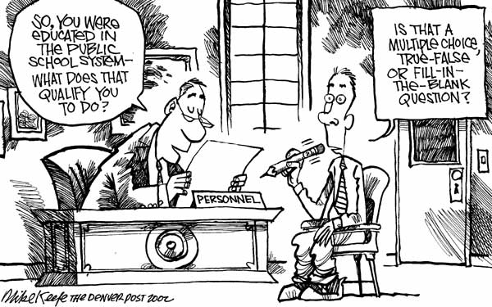

Document #3

1) How do you think the artist views standardized testing? __________________________________________________
__________________________________________________________________________________________________
__________________________________________________________________________________________________
2) What does this cartoon say about public school system? __________________________________________________
____________________________________________________________________________________________________________________________________________________________________________________________________

Document #4
"Testing has been a valuable part of the educational process since the days of Socrates. There is nothing new or scary about it. It lets teachers and parents know how kids are doing and lets students see the rewards of hard work. That's why assessments are part of the No Child Left Behind Act. The law's emphasis on high standards and accountability has led to a sharp focus on results.Students are no longer overlooked and shuffled from grade to grade, whether they have learned the material or not. The achievement gap between rich and poor and black and white is no longer treated as a sad fact of life, but rather as a problem to be solved.”
–Margaret Spellings, US Secretary of Education 2005-2009, Editorial October 14, 2005

1) What is Spellings’s point of view of No Child Left Behind? ______________________________________________
____________________________________________________________________________________________________________________________________________________________________________________________________
2) Do you think testing is the best way to measure if students have learned the material? Do you believe it prevents students from being “shuffled from grade to grade”? _______________________________________________________
______________________________________________________________________________________________________________________________________________________________________________________________________________________________________________________________________________________________________

*Part 3: In part three you reread the BIG Question, and then start to brainstorm about how the documents connect to the question. You can create concept webs, an outline, whatever your English teacher taught you for Pre-Writing. During this process you should form your Own Opinion on the question. Do part 3 on another sheet of paper.

*Part 4: Now that you have formed your opinion and have analyzed the documents, you need a Topic Sentence to start your Essay.
Topic Sentence: ____________________________________________________________________________________
____________________________________________________________________________________________________________________________________________________________________________________________________

*Part 5: You now are ready to write your essay. Remember you must use the documents not just your opinion as evidence! Your Essay should include….
- Introduction – Discuss the Question\Thesis and include your Topic Sentence (3-5 sentences)
- 2 Body paragraphs- Discuss each document as evidence for your Answer and Opinion (5-8 sentences each). Use evidence to defend your opinion and to counter the opposing view point.
- Conclusion – Wrap up with your Main Idea again and any final points (3-5 sentences)

