Name:________________ Date:_____________
MYP/Vanguard Texas History Class Period: ______

Texas Empresarios: Cheap land, come and take it!
Stephen F. Austin
Where was my colony located?

What group of immigrants settled in my colony?

What is my contribution to Texas history?
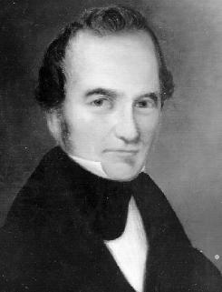

Erasmo Seguín
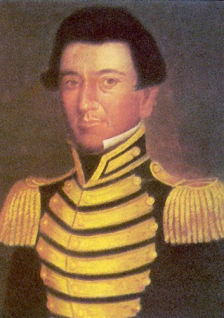
What was my job?

What was my role during the Anglo settlement of Texas?

What is my contribution to Texas history?

Green DeWitt
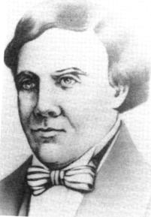
Where was my colony located?

What group of immigrants settled in my colony?

What is my contribution to Texas history?

Martín De León
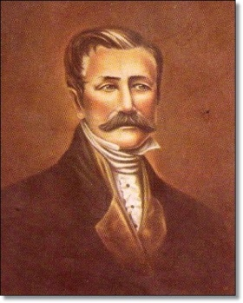
Where was my colony located?

What group of immigrants settled in my colony?

What is my contribution to Texas history?

Benjamin Milam
Where was my colony located?

What group of immigrants settled in my colony?

What is my contribution to Texas history?

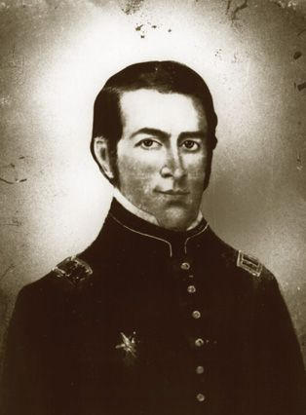

Lorenzo de Zavala
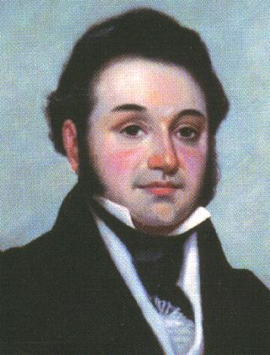
Where was my colony located?

What group of immigrants settled in my colony?

What is my contribution to Texas history?

Haden Edwards
Where was my colony located?

What group of immigrants settled in my colony?

What is my contribution to Texas history?

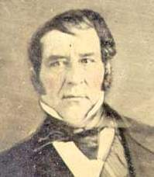
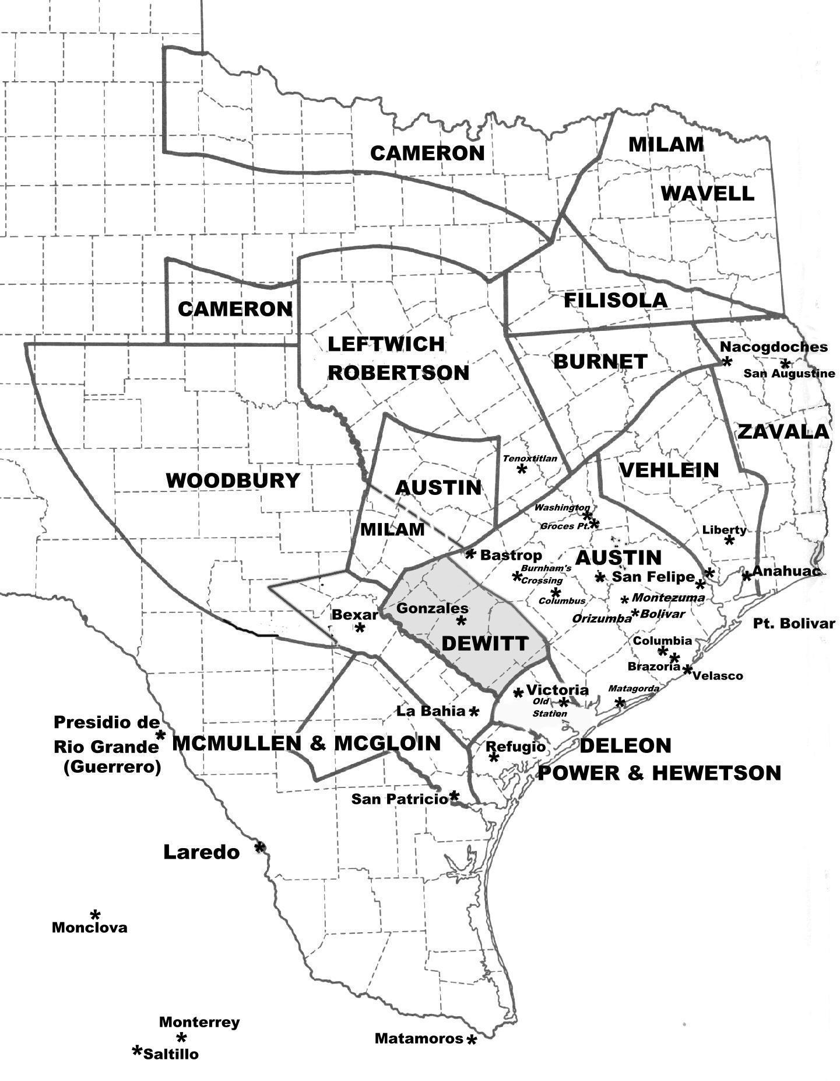

Stephen F. Austin
Stephen Fuller Austin, founder of Anglo-American Texas, son of Moses and Maria (Brown) Austin, was born at the lead mines in southwestern Virginia on November 3, 1793. In 1798 Moses Austin moved his family to other lead mines in southeastern Missouri and established the town of Potosi in what is now Washington County. From there his father decided that Texas needed to be explored and settled for American citizens. Though not enthusiastic about the Texas venture, Austin decided to cooperate with his father. He arranged to obtain a loan from his friend Hawkins to float the enterprise and was at Natchitoches expecting to accompany his father to San Antonio when he learned of Moses Austin's death. He proceeded to San Antonio, where he arrived in August 1821. Authorized by Governor Antonio María Martínez to carry on the colonization enterprise under his father's grant, Austin came to an understanding about certain administrative procedures and was permitted by the governor to explore the coastal plain between the San Antonio and Brazos rivers for the purpose of selecting a site for the proposed colony. Among other details, he arranged with Martínez to offer land to settlers in quantities of 640 acres to the head of a family, 320 acres for his wife, 160 acres for each child, and 80 acres for each slave. For such quantity as a colonist desired, Austin might collect 12½ cents an acre in compensation for his services. Martínez warned Austin that the government was unprepared to extend administration over the colonists and that Austin must be responsible for their good conduct.
In August 1824 a new congress passed an immigration law that vested the administration of public land in the states, with certain restrictions, and authorized them to make laws for settlement. In March 1825 the legislature of Coahuila and Texas passed a law conforming in general to the previous act approved by Iturbide. It continued the empresario system contemplated by that law and offered to each married man a league of land (4,428 acres), for which he was obligated to pay the state thirty dollars within six years. In the meantime, Austin had substantially fulfilled his contract to settle the first 300 families. Under this state law, he obtained three contracts (in 1825, 1827, and 1828) to settle a total of 900 additional families in the area of his first colony, besides a contract in partnership with his secretary, Samuel M. Williams, for the settlement of 800 families in western Texas. Unfortunately, this partnership contract led to a disagreeable controversy with Sterling C. Robertson.
Besides bringing the colonists to Texas, Austin strove to produce and maintain conditions conducive to their prosperous development. This aim coincided, in general, with that of the government. For example, by an act of September 1823, the federal government relieved the colonists of the payment of tariff duties for seven years; and the state legislature was nearly always reasonably cooperative. Mexican sentiment sometimes clashed, however, with practical needs of the colonists, and Austin had to evolve or accept a compromise. The status of slavery was always a difficult problem, and Austin's attitude from time to time seems inconsistent. With almost no free labor to be hired and expecting most of the colonists to come from the slave states, Austin prevailed on the junta instituyente to legalize slavery in the imperial colonization law, under which the first colony was established.
Aware of the importance of external trade, Austin consistently urged the establishment of ports and the temporary legalization of coasting trade in foreign ships. In lengthy arguments to various officials, he declared that the coasting trade would establish ties of mutual interest between the colonists and Mexico and enable Mexico to balance imports from England by exporting Texas cotton. Congress legalized the port of Galveston after a survey of the pass by Austin in 1825, and the government winked at the use of the Brazos and other landing places, but the coasting trade in foreign vessels was not established. As a result, external trade was confined to the United States.

The Law of April 6, 1830, embodied the Mexican policy of stopping the further colonization of Texas by settlers from the United States. The law proposed to annul general empresario contracts uncompleted or not begun and prohibited settlement of immigrants in territory adjacent to their native countries. In effect, it applied only to Texas and the United States. By ingenious and somewhat tortuous interpretation, Austin secured the exemption of his own colonies and the colony of Green DeWitt from the prohibition. He thereby gained a loophole for continued immigration from the United States and then turned industriously to the task of getting the law repealed. He succeeded in this in December 1833. He continued to fight for Texas even after the looming revolution broke out.
Judged by historical standards, Austin did a great work. He began the Anglo-American colonization of Texas under conditions more difficult in some respects than those that confronted founders of the English colonies on the Atlantic coast. He saw the wilderness transformed into a relatively advanced and populous state, and fundamentally it was his unremitting labor, perseverance, foresight, and tactful management that brought that miracle to pass.

BIBLIOGRAPHY:
Eugene C. Barker, ed., The Austin Papers (3 vols., Washington: GPO, 1924–28). Eugene C. Barker, The Life of Stephen F. Austin (Nashville: Cokesbury Press, 1925; rpt., Austin: Texas State Historical Association, 1949; New York: AMS Press, 1970). Rupert N. Richardson, Texas: The Lone Star State (New York: Prentice-Hall, 1943; 4th ed., with Ernest Wallace and Adrian N. Anderson, Englewood Cliffs, New Jersey: Prentice-Hall, 1981).

Haden Edwards
Haden (or Hayden) Edwards, pioneer settler and land speculator, was born in Stafford County, Virginia, on August 12, 1771, the son of John Edwards. In 1780 the family moved to Bourbon County, Kentucky (at that time part of Virginia), where John Edwards acquired 23,000 acres of land, worked for statehood, and was elected to the United States Senate. Haden was educated for the law but like his father was more interested in land speculation. In 1820 he married Susanna Beall of Maryland, and they moved to the area of Jackson, Mississippi, where he and his brother Benjamin W. Edwards acquired a plantation. He and Susanna eventually had thirteen children. In Mississippi the Edwardses first heard the news of Moses Austin's plans for colonization in Texas. In 1823 Edwards traveled to Mexico City, where he joined Stephen F. Austin, Robert Leftwich, and others in a three-year attempt to persuade various Mexican governments to authorize American settlement in Texas. Because of his wealth Edwards was often called upon to finance Austin. Their efforts resulted in the colonization law of 1824 in Mexico City and of 1825 in Saltillo, which allowed empresarios to introduce settlers to Texas. Edwards suffered more than he profited from his relationship with Austin, at least in his own mind, since he believed that Austin claimed the best lands and tried to push his boundaries in every direction at the expense of other empresarios.
Edwards received a grant in the vicinity of Nacogdoches where he could locate 800 families. Like other empresarios he agreed to honor preexisting grants and claims made by Spanish or Mexican officials. Of all empresarios, Edwards probably had the most such claims, some over a century old. In 1825 he posted notices to inform all potential claimants that they must come forward with proof of their claims or he would consider the land his, subject to sale to new settlers. This angered the older settlers, who opposed Edwards until he was expelled two years later. He also became involved in an election dispute between the representative of the older settlers, Samuel Norris, and Chichester Chaplin, Edwards's son-in-law. As empresario, Edwards certified the election of Chaplin. Norris then protested to Governor José Antonio Saucedo in San Antonio, and Saucedo upheld Norris's claim to office. However, Chaplin continued to hold the position until Norris requested aid from the local militia. Continued complaints from the area caused Edwards to come under suspicion, and his brother Benjamin, who handled business affairs while Haden was absent from Texas in 1826, addressed such strident correspondence to government officials that it resulted in the revocation of the Edwards grant in October of that year.
Edwards was shocked by this turn of events. He had invested more than $50,000 to secure and launch the grant, and he did not willingly surrender it. Additionally, the cancellation of his grant resulted in the forfeiture of the claims of all settlers who had moved onto his lands. Thus, when the events known as the Fredonian Rebellion, which the Edwards brothers eventually headed, began the following month, the Edwards grantees were most supportive. In November 1826 Edwards was arrested as a ruse. When no one appeared at his trial as an accuser he was freed, but Norris and militia chief José Antonio Sepúlveda were found guilty and judged deserving of the death sentence, which was commuted to banishment from office by this extralegal tribunal. News of the uprising reached the Mexican authorities, who dispatched Lt. Col. Mateo Ahumada to Nacogdoches. Learning that troops were on their way, Martin Parmer and Benjamin Edwards recruited the Ayish Bayou militia to come to town as well. They signed articles establishing the Fredonian Republic, with Haden Edwards as its leader. An alliance was also made with Cherokee Indians led by Richard Fields and John Dunn Hunter, who also had grievances against the government. Before an armed clash occurred the Fredonians dispersed, in early February 1827, and Edwards fled to Louisiana for safety. He returned to Texas during the Texas Revolution and made his home in Nacogdoches until his death, on August 14, 1849. Edwards was the first worshipful master of Milam Lodge No. 2 when it was organized in 1837, a fact that indicates his status in the Anglo leadership. Until his death he was engaged in the land business.

BIBLIOGRAPHY:
Biographical Files, Special Collections, Steen Library, Stephen F. Austin State University. Archie P. McDonald, comp., Nacogdoches: Wilderness Outpost to Modern City, 1779–1979 (photocopy, Dolph Briscoe Center for American History, University of Texas at Austin). Edward Morris Parsons, the Fredonian Rebellion," Texana, Spring 1967.

Lorenzo De Zavala
Manuel Lorenzo Justiniano de Zavala y Sáenz, first vice president of the Republic of Texas, the fifth of nine children of Anastasio de Zavala y Velázquez and María Bárbara Sáenz y Castro, was born in the village of Tecoh near Mérida, Yucatán, on October 3, 1788. After graduating from the Tridentine Seminary of San Ildefonso in Mérida in 1807, he founded and edited several newspapers in which he expressed those democratic ideas that were to be the hallmark of his political career, ideas which he continued to advocate while serving as secretary of the city council of Mérida from 1812 until 1814. His support of democratic reforms led to his imprisonment in 1814 in the fortress of San Juan de Ulloa in the harbor of Veracruz, where he gained enough knowledge from reading medical textbooks to qualify him to practice medicine upon his release from prison in 1817. He also taught himself to read English during his imprisonment. After serving as secretary of the provincial assembly of Yucatán in 1820, Zavala went to Madrid in 1821 as a deputy to the Spanish Cortes. Upon his return to Mexico, he joined the leaders of the new nation in establishing a republican government. From 1822 until his death, he was one of the nation's most active political leaders, representing Yucatán as a deputy in the First and Second Mexican Constituent congresses of 1822 and 1824 and in the Mexican Senate from 1824 to 1826. In the following two years, marked by the internecine struggle between the Federalists and Centralists for control over both national and state governments, Zavala served intermittently as governor of the state of Mexico. When Vicente Ramón Guerrero became president, Zavala was appointed secretary of the treasury and served from April to October 1829. When the Centralist party, led by Vice President Anastacio Bustamante, ousted Guerrero late in the year, Zavala, a strong Federalist, was forced to abandon politics and, after a period of house arrest, to go into exile in June 1830.
Upon his arrival in New York, Zavala sought to interest eastern capitalists in the empresario grants he had received on March 12, 1829, which authorized him to settle 500 families in a huge tract of land in what is now southeastern Texas. In New York City, in October 1830, he transferred his interest in the grants to the Galveston Bay and Texas Land Company. After spending several months during 1831 in France and England, Zavala resided in New York City until his return to Mexico in the summer of 1832. From December 1832 until October 1833 he again served as governor of the state of Mexico, before returning to the Congress as a deputy for his native state of Yucatán. Named by President Antonio López de Santa Anna in October 1833 to serve as the first minister plenipotentiary of the Mexican legation in Paris, he reported to that post in the spring of 1834. When he learned that Santa Anna had assumed dictatorial powers in April of that year, Zavala denounced his former ally and resigned from his diplomatic assignment. Disregarding Santa Anna's orders to return to Mexico City, he traveled to New York and then to Texas, where he arrived in July 1835. From the day of his arrival, he was drawn into the political caldron of Texas politics. Although he first advocated the cause of Mexican Federalism, within a few weeks he became an active supporter of the independence movement; he served in the Permanent Council and later as the representative of Harrisburg in the Consultation and the Convention of 1836.
Zavala's legislative, executive, ministerial, and diplomatic experience, together with his education and linguistic ability, uniquely qualified him for the role he was to play in the drafting of the constitution of the Republic of Texas. His advice and counsel earned him the respect of his fellow delegates, who elected him ad interim vice president of the new republic. In the weeks after adjournment of the convention, Zavala rejoined his family at their home at Zavala Point on Buffalo Bayou, from where they fled to Galveston Island as Santa Anna's army pursued Zavala and other cabinet members across Texas. In accordance with the provisions of the Treaties of Velasco, Zavala was appointed, on May 27, 1836, one of the peace commissioners to accompany Santa Anna to Mexico City, where the general was to attempt to persuade the Mexican authorities to recognize the independence of Texas. The frustration of this plan by certain Texas military units brought an end to the peace commission. Shortly thereafter, Zavala returned to his home in poor health and relinquished his part in the affairs of state. He resigned the vice presidency on October 17, 1836. Less than a month later, soaked and half-frozen by a norther after his rowboat overturned in Buffalo Bayou, he developed pneumonia, to which he succumbed on November 15, 1836. He was buried at his home in a small cemetery plot marked by the state of Texas in 1931. The plot has since sunk into Buffalo Bayou. In the twenty-five years after 1807 when Zavala became politically active, he demonstrated his skills as a writer in uncounted articles and editorials in newspapers in Mérida and Mexico City, and in a large number of pamphlets and memorials.

BIBLIOGRAPHY:
Raymond Estep, The Life of Lorenzo de Zavala (Ph.D. dissertation, University of Texas, 1942). Raymond Estep, "Lorenzo de Zavala and the Texas Revolution," Southwestern Historical Quarterly 57 (January 1954). Margaret Swett Henson, Lorenzo de Zavala (Fort Worth: Texas Christian University Press, 1996).

Benjamin Milam
Ben Milam, soldier, colonizer, and entrepreneur, was born in Frankfort, Kentucky, on October 20, 1788, the fifth of the six children of Moses and Elizabeth Pattie (Boyd) Milam. He had little or no formal schooling. He enlisted in the Kentucky militia and fought for several months in the War of 1812. When his period of enlistment was completed he returned to Frankfort. In 1818 he was in Texas trading with the Comanche Indians on the Colorado River when he met David G. Burnet. The two became friends. In New Orleans in 1819 Milam met José Félix Trespalacios and James Long,^{qqv} who were planning an expedition to help the revolutionaries in Mexico and Texas gain independence from Spain. Milam joined Trespalacios and was commissioned a colonel. While they sailed to Veracruz, Long marched to La Bahía, which he easily captured, only to discover that the people and soldiers there were revolutionaries, not Royalists. They gave him a hostile reception, and he moved on to San Antonio. In Veracruz and Mexico City, Trespalacios and Milam met with the same reception that Long had received and were imprisoned. Ultimately, with General Long, they were able to legitimatize their purposes and intentions to the new revolutionary government which, in turn, accepted and treated them with respect and generosity. Long was shot and killed by a guard under circumstances that convinced Milam that the killing was plotted by Trespalacios. Milam and several friends then planned to kill Trespalacios. The plot was discovered, however, and Milam and his friends were imprisoned in Mexico City. Through the influence of Joel R. Poinsett, United States minister, all were released.
By the spring of 1824 Milam returned to Mexico, which now had adopted the Constitution of 1824 and had a republican form of government. In Mexico City he met Arthur G. Wavell, an Englishman who had become a general in the Mexican army. Trespalacios, now prominent in the new government also, made overtures to Milam to renew their friendship, and Milam accepted. He was granted Mexican citizenship and commissioned a colonel in the Mexican army in 1824. In 1825–26 he became Wavell's partner in a silver mine in Nuevo León; the two also obtained empresario grants in Texas. Wavell managed the mining in Mexico and leased the most productive mine to an English company, which by 1828 was unable to fulfill the terms of their contract. In 1829 Milam sought to organize a new mining company in partnership with David G. Burnet, but they were unable to raise the necessary capital.
In April 1830 the Mexican Congress passed a law prohibiting further immigration of United States citizens into Texas (see LAW OF APRIL 6, 1830). This was one reason why Milam, as Wavell's agent for his Red River colony, and Robert M. Williamson, as agent for Milam's colony, were not able to introduce the required number of settlers specified in their empresario contracts, which were due to expire in 1832. During this time Milam removed the great Red River raft of debris, which for years had blocked traffic in the upper part of the Red River for all vessels except canoes and small, flat-bottomed boats. He then purchased a steamboat, the Alps, the first of its kind to pass through the channel.
In 1835 Milam went to Monclova, the capital of Coahuila and Texas, to urge the new governor, Agustín Viesca, to send a land commissioner to Texas to provide the settlers with land titles. Viesca agreed to do this. However, before Milam could leave the city, word came that Antonio López de Santa Anna had overthrown the representative government of Mexico, had established a dictatorship, and was en route to Texas with an army. Viesca fled with Milam, but both were captured and imprisoned at Monterrey. Milam eventually escaped and headed for the Texas border, which he reached in October 1835. By accident he encountered a company of soldiers commanded by George Collinsworth, from whom he heard of the movement in Texas for independence. Milam joined them, helped capture Goliad, and then marched with them to join the main army to capture San Antonio. While returning from a scouting mission in the southwest on December 4, 1835, Milam learned that a majority of the army had decided not to attack San Antonio as planned but to go into winter quarters. Convinced that this decision would be a disaster for the cause of independence, Milam then made his famous, impassioned plea: "Who will go with old Ben Milam into San Antonio?" Three hundred volunteered, and the attack, which began at dawn on December 5, ended on December 9 with the surrender of Gen. Martín Perfecto de Cos and the Mexican army. Milam did not survive to witness the victory, however. On December 7 he was shot in the head by a sniper and died instantly. In 1897 the Daughters of the Republic of Texas erected a monument at Milam's gravesite in Milam Park, San Antonio. The marker was moved in 1976, and the location of the grave was forgotten until 1993, when a burial was unearthed that archeologists think is probably Milam's.

BIBLIOGRAPHY:
Robert W. Amsler, "General Arthur G. Wavell: A Soldier of Fortune in Texas,"Southwestern Historical Quarterly 69 (July 1965). Lois A. Garver, "Benjamin Rush Milam,"Southwestern Historical Quarterly 38 (October 1934, January 1935). Lois A. Garver, The Life of Benjamin Rush Milam (M.A. thesis, University of Texas, 1931). Rex W. Strickland, Anglo-American Activities in Northeastern Texas, 1803–1845 (Ph.D. dissertation, University of Texas, 1937). Vertical Files, Dolph Briscoe Center for American History, University of Texas at Austin.

Martín De León
Martín De León, the only Mexican empresario to found a colony in Texas, was born in 1765 in Burgos, Nuevo Santander (now Tamaulipas), where his parents, Bernardo and María Galván De León, settled after moving from Burgos, Spain. The De Leóns were an aristocratic family of great wealth; members were educated in Madrid, Paris, and London and were acquainted with European rulers. Martín, however, declined his father's offer to complete his education in Monterrey and Europe, choosing instead to become a merchant and supplier of provisions to the miners of Real de San Nicolás. In 1790 he joined the Fieles de Burgos regiment, organized by Mexican viceroy Juan Vicente Guernes Pacheco as a defense against Indians in Nuevo Santander. De León was promoted to captain, thus achieving the highest rank available to a criollo. In 1795 he married Patricia de la Garza, daughter of Gen. Felipe de la Garza, commandant of the Eastern Internal Provinces. The couple settled in Cruillas, Nuevo Santander (now Tamaulipas), where they began ranching. An excursion to La Bahía, San Antonio, and Nacogdoches in 1805 induced De León to settle in Texas. He established a ranch between Chiltipin Creek and the Aransas River, stocked it with cattle, horses, mules, and goats that he brought from Mexico, and enclosed several leagues of land with a brush fence in an effort to corral and domesticate mustangs.
In 1807 De León petitioned the Spanish governor at San Antonio, Manuel María de Salcedo, to establish a colony in this vicinity. The government, however, denied this request as well as a second one in 1809, as a result of rising political troubles in Mexico and rumors that the De Leóns were not loyal to Spain. De León then established a new ranch on the east bank of the Nueces River near the site of present San Patricio, where he enclosed another pasture. He had by this time driven several herds of livestock to market at New Orleans, thus becoming one of the earliest traildrivers in Texas. Texas presidio garrisons were moved as a result of the uprising in September 1810 of Father Miguel Hidalgo y Costilla. Because the frontier then became vulnerable to hostile Lipans and Comanches, De León removed his family to the safety of San Antonio, where he joined the Republicans in resisting the Royalists under Joaquín de Arredondo and Ignacio Elizondo. After a respite in Burgos in 1816 De León returned to his ranch and cattle, now numbering about 5,000 head. In 1823 he drove a large herd of livestock to New Orleans and became interested in settling a colony on the lower Guadalupe River.
Mexican independence from Spain brought a more open colonization policy. On April 8, 1824, De León petitioned the provincial delegation at San Fernando de Béxar to settle forty-one Mexican families on the lower Guadalupe and founded the town of Nuestra Señora Guadalupe de Jesús Victoria. The colonization grant was approved on April 13. Patricia De León contributed $9,800 and cows, horses, and mules valued at $300, which she inherited from her father. De León's colony was the only predominantly Mexican colony in Texas, and as a Mexican citizen the empresario received legal preference in the numerous border disputes with American settlements encircling Guadalupe Victoria.
De León stood six feet tall and was skilled as a horseman and Indian fighter; Indians called him "Capitán Vacas Muchas" ("Captain Plenty of Cows") since he often placated raiding parties by feeding them beef. His five-league (22,140-acre) ranch was located on Garcitas Creek in what is now southeastern Victoria County and probably included the site of La Salle's Fort St. Louis. His thousands of cattle carried the first brand in Texas, an E and J connected, signifying "Espíritu de Jesús." De León registered the historic brand in 1807; Jesuits had used it for hundreds of years before the royal De León family in Spain adopted it. De León's ranchland, though considerably less extensive than that of later cattlemen, provided a foundation for one of the characteristic industries of Texas. As a devout Catholic, De León was planning to build a church without rival in Texas when he became a victim of the cholera epidemic of 1833 and died, leaving his widow, four sons, and six daughters an estate of over a half million dollars.

BIBLIOGRAPHY:
Joe Tom Davis, Legendary Texians (3 vols., Austin: Eakin Press, 1982–86). A. B. J. Hammett, The Empresario Don Martín de León (Waco: Texian Press, 1973). Victor Marion Rose,History of Victoria (Laredo, 1883; rpt., Victoria, Texas: Book Mart, 1961).

Erasmo Seguín
Erasmo Seguín, San Antonio political figure, postmaster, and businessman, the third of seven children of Santiago Seguín and María Guadalupe Fuentes, was born in San Antonio on May 26, 1782. Sometime after 1800 he married María Josefa Becerra, daughter of a noncommissioned officer of La Bahía Presidio. Of their three children, Juan Nepomuceno Seguín became an important military and political figure of the Texas Revolution and republic periods. Erasmo Seguín's public career began in 1807 when he became San Antonio postmaster, a position he held until October 1835 with only two interruptions. He opposed the Casas Revolt, which broke out in San Antonio in January 1811, helped lead the counter revolt, and served on the local governing council until royalist officers returned. Nevertheless, during the 1812–13Gutiérrez-Magee expedition, he came under suspicion of collaborating with revolutionaries, had his property confiscated, and was removed from office as postmaster. Unwilling to accept a pardon, he was exonerated in 1818 but did not regain the postmastership until 1822. Shortly before independence he was elected alcalde of San Antonio, the first of a number of local offices he held during the Mexican and early Republic of Texas periods. In 1825 he received an appointment from the federal government as quartermaster for the San Antonio garrison.
Seguín received a number of other public trusts. In 1821 Governor Antonio Martínez appointed him to inform Moses Austin that the latter's petition to start a colony in Texas had been approved. The Convention of 1833 appointed Seguín as one of three representatives to present Texas's grievances to the national government, although he declined the assignment. Following Texas independence he served briefly as a magistrate in San Antonio. Seguín's most important commission, however, was his service as Texas representative to the congress that wrote the Constitution of 1824. From December 1823 to September 1824 Seguín worked in Mexico City to promote the interests of both his native San Antonio and the Anglo-American settlers. As a member of the colonization committee he worked on the liberal National Colonization Law of August 18, 1824, which left most issues of immigration and land distribution in the hands of the state governments. While he reluctantly accepted the union of Coahuila and Texas, he worked for the inclusion of a provision allowing Texas to petition for separate statehood at a future date. Seguín also worked for a loose interpretation of the requirement that settlers be Catholic and against the complete abolition of slavery.
Upon his return to San Antonio late in 1824, Seguín labored to build up his economic position. Having recovered possession of the property confiscated during the Mexican War of Independence, which included a large ranch previously belonging to San Antonio de Valero Mission, he added to his holdings a 9,000 acre tract at a site near present Floresville. There he made an effort to become a cotton planter. Seguín also developed business and personal ties to Stephen F. Austin, who often stayed with the Seguíns during his travels through the area. At the outbreak of the Texas rebellion in October 1835, Gen. Martín Perfecto de Cos removed Seguín from office and forced him to march to his ranch thirty miles east of San Antonio. Casa Blanca, as the estate was known, became a source of supply of beef cattle, horses, mules, and corn to the Texas army. In 1840 the Texas Congress compensated Seguín in the amount of $3,004 for the supplies he furnished. Seguín's interests not only suffered at the hands of the Mexican army, but at the hands of Anglo-American rustlers, who as late as 1842 made off with a sizable number of cattle from his ranch. In that same year Thomas Jefferson Green accused Seguín of collaborating with Mexico, a charge that found no support among other Anglo Americans. During the 1840s and 1850s Erasmo Seguín dedicated himself to his ranch, where he died on October 30, 1857.

BIBLIOGRAPHY:
Jesús F. de la Teja, ed., A Revolution Remembered: The Memoirs and Selected Correspondence of Juan N. Seguín (Austin: State House Press, 1991). Vertical Files, Dolph Briscoe Center for American History, University of Texas at Austin.

Green DeWitt
Green DeWitt, empresario of DeWitt's colony, was born on February 12, 1787, in Lincoln County, Kentucky. While he was still an infant, his father moved the family to the Spanish-held territory of Missouri. Although little is known of his father's activities there, the family was prominent enough to educate Green beyond the normal rudimentary level, and when the boy turned eighteen he returned to Kentucky for two years to complete his education. He then returned to Missouri, where he married Sarah Seely of St. Louis in 1808. DeWitt enlisted in the Missouri state militia in the War of 1812 and achieved the rank of captain by the war's end. He then served for a time as sheriff of Ralls County. In 1821 he was inspired by Moses Austin's widely circulated success in obtaining a grant from the Spanish government to establish a colony in Texas. As early as 1822 he petitioned the Mexican authorities for his own empresario contract, but was unsuccessful. Having seen Texas and visited Austin, DeWitt journeyed in March 1825 to Saltillo, the capital of the Mexican state of Coahuila and Texas, where he petitioned the state government for a land grant. Aided by Austin and the Baron de Bastrop, he was awarded an empresario grant on April 15, 1825, to settle 400 Anglo-Americans on the Guadalupe River and was authorized to establish a colony adjacent to Stephen F. Austin's subject to the Colonization Law of 1824. He was accused of having misappropriated public funds in Missouri by Peter Ellis Bean before the jefe político at San Antonio shortly after he received his grant, but was exonerated on October 16, 1825, after Stephen F. Austin investigated the matter.
Sara Seely DeWitt contributed to her husband's venture with the profits from the sale of her property in Missouri. By October 1825 Green DeWitt was inspecting the work already done in his colony by his surveyor, James Kerr. After a few weeks he returned to Missouri to promote the colony. By April 1826 he was bringing to Texas his wife, two sons, three of four daughters, and three other families. The group joined those already in the colony, who eventually settled at Gonzales. For almost the next decade DeWitt worked with Byrd Lockhart, José Antonio Navarro, Charles Lockhart, Kerr, and others to develop the colony. As his contemporary, Noah Smithwick, later said of the empresario, he "was as enthusiastic in praise of the country as the most energetic real estate dealer of boom towns nowadays." Because the Mexican government had not specified a boundary between DeWitt's grant and the earlier grant made to Martín De León further south on the Guadalupe River, the two empresarios had numerous disputes involving boundaries and contraband trade, resulting in irreparable damage to their relationship.
DeWitt apparently did not have the degree of personal influence over his settlement that Austin exercised at San Felipe. Although he represented the District of Gonzales in the Convention of 1833, he never held an elected office in the colony's government. Despite his apparent success in establishing the colony, he was unable to fulfill his contract by the time it expired on April 15, 1831, and he failed to get it renewed. He spent his last years engaging in some limited commercial investments and improving his own land on the right bank of the Guadalupe River across from the Gonzales townsite, premium land given him as empresario. For the most part, however, his colony proved neither materially nor financially rewarding for him. He had apparently invested all his family's resources in his struggling colony, and as early as 1828 its problems compelled one visitor, though impressed with the empresario, to note that "dissipation [and] neglectful indolence have destroyed his energies." Indeed, DeWitt endorsed his wife's petition in December 1830 to the ayuntamiento of San Felipe de Austin asking for a special grant of a league of land in her maiden name "to protect herself and family from poverty to which they are exposed by the misfortunes of her husband." The Mexican government complied in April 1831. DeWitt colonists in general suffered similarly. Smithwick related that "money was as scarce as bread," and pelts were used as barter. DeWitt did issue, however, what was essentially land scrip in denominations of five, ten, and twenty dollars, for his colonists to buy their lands; the handwritten currency was transferable and generally passed as a medium of exchange. Green DeWitt money is one of the earliest examples of Texas paper currency.
In an attempt to improve his economic position and to secure premium land for settling eighty families, DeWitt journeyed in 1835 to Monclova, where he hoped to buy unlocated eleven-league grants from the governor, who was attempting to raise money for defense through land sales. But he failed to acquire any land. While in Monclova DeWitt contracted a fatal illness, probably cholera. He died on May 18, 1835, and was buried there in an unmarked grave. Though he did not live to see the battle of Gonzales, which traditionally is considered the first skirmish of the Texas Revolution, his wife and daughter, Naomi, cut up Naomi's wedding dress to make the "Come and Take It" banner that his fellow colonists adopted as their battle flag. Sara DeWitt, who was born in Brooke County, Virginia, on June 29, 1787, died in Gonzales on November 28, 1854. The Sara Seely grant was one of the few DeWitt colony land grants issued by the Mexican government to a woman.
BIBLIOGRAPHY:
John Henry Brown, History of Texas from 1685 to 1892 (2 vols., St. Louis: Daniell, 1893). Edward Albert Lukes, De Witt Colony of Texas (Austin: Jenkins, 1976). Ethel Zivley Rather, "DeWitt's Colony," Quarterly of the Texas State Historical Association 8 (October 1904). Noah Smithwick, The Evolution of a State, or Recollections of Old Texas Days (Austin: Gammel, 1900; rpt., Austin: University of Texas Press, 1983). William S. Speer and John H. Brown, eds.,

