**CLASS SET- DO NOT WRITE ON!**

**Mexico Declares Independence**

**As you read, take any notes you think are important and write your answers in complete sentences in your notebook.**

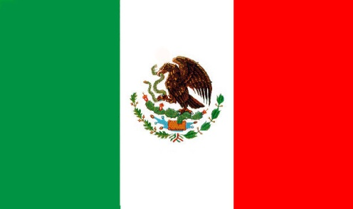

The people of Mexico are a blend of Native American and Spanish. The people don't identify themselves as Native American or Spanish though. They consider themselves a mixture of the two. The official language in Mexico is Spanish and the major religion is Catholic.

**1. Mexicans are a mix of what two groups of people?**

In the early nineteenth century the Mexicans were discussing how to revolt against Spain. This thought of revolting was influenced by Revolutions in America and France years before. Many Mexicans did not like being ruled by Spain. The best jobs in Mexico were given to men sent from Spain (Penisulares). Furthermore, Spain taxed Mexicans to help pay for wars in Europe.

**2. What inspired/influenced Mexican Independence?**

**3. Why were many Mexicans unhappy with Spanish rule?**

There were several groups starting to rally the people for this cause. A leader of one of these groups was a priest named Father Miguel Hidalgo. Hidalgo lived in Dolores, Mexico. Hidalgo and his officers were planning a revolt for late fall of 1810. There were things that they needed to do to prepare the people for the revolt. They needed to make swords, bullets, and train the Indians how to fight. The Spanish people found out about the revolt and the Spanish government ordered the arrest of Hidalgo and his officers. When Hidalgo heard about this he called a meeting at his church. He rang the church bell on the night of September 15, 1810 to call his congregation to the church for a mass. When all the people arrived Father Hidalgo rallied the people to fight. He gave the speech that is now called Grito de Delores. He said "Viva Mexico" and "Viva la independencia!" These famous words he said have been remembered and are said each year at Independence Day celebrations.

**4. Who rallied Mexicans to fight for their independence?**

**5. What was his speech called?**

**6. What famous words are said every year on Independence Day?**

All the people fought together, Criollos (wealthy Mexicans of Spanish blood), Mesizos (children born of a marriage of a Spaniard and an Native American), and Native Americans. The people used clubs, knives, stone slings, and ancient guns. The people marched to Mexico City and along the way they fought. When they finally reached the capital, the army hesitated before going in to fight. When they hesitated some of the people deserted the army. Before the year was over Father Hidalgo was captured and executed. Other people continued to fight for the cause and Father Hidalgo's Grito de Delores (Cry of Delores) became the battle cry of the Mexican War of Independence. The people fought for eleven years before they finally won their freedom.

**7. What three groups of people fought together for independence?**

**8. What happened to Father Hidalgo?**

**9. How long was the fight for independence?**

Today Mexican Independence Day is a major celebration in Mexico, bigger than Cinco de Mayo. The people of Mexico celebrate with a fiesta. The celebrating begins on September 15 (the eve of Independence Day) by having crowds of people gather in the zocalos (town meeting place) of cities, towns, and villages. In Mexico City a huge square is decorated with flags, flowers and lights of red, white, and green. People sell confetti, whistles, horns, paper-machete helmets, and toys in the colors of red, white and green. The people also eat lots of food.

The people watch the time and when the clock strikes eleven o'clock the crowd gets silent. On the last strike of eleven the president of Mexico steps out on the palace balcony, and rings the historic liberty bell that Father Hidalgo rang to call the people. Then the president gives the Grito de Delores. He shouts "Viva Mexico" "Viva la independencia" and the crowd echos back. People do this at the same time all across Mexico. While the crowd says this they fill the air with confetti, streamers and noise. Castillos explode in showers of red, white, and green. Then people go home and sleep for the next days' celebration.

**10. What is read every year on Independence Day?**

The actual day of September 16 is similar to July Fourth in the United States. There are rodeos, parades, bullfights and horseback rider performances. The people feast and recall Hidalgo's speeches. There are statues in memory of Father Hidalgo and people decorate them with flowers that are red, white, and green.

**11. What is the date of Mexican Independence?**

**12. What is the date of U.S. Independence?**

The Mexican Flag is made of three main colors; green, white, and red. These colors all symbolize something and have an important part in the celebrations. The green is on the left side of the flag and symbolizes independence. White is the color in the middle of the flag and symbolizes religion. The red is on the right side of the flag and symbolizes union. These colors are used often in decorating for the Mexican Independence Day fiesta.

**13. What does each color on the Mexican flag represent?**