Name ______________________________ Period_____________________
Date _______________________________ Vanguard Texas History

Massacre at Goliad and the Runaway Scrape
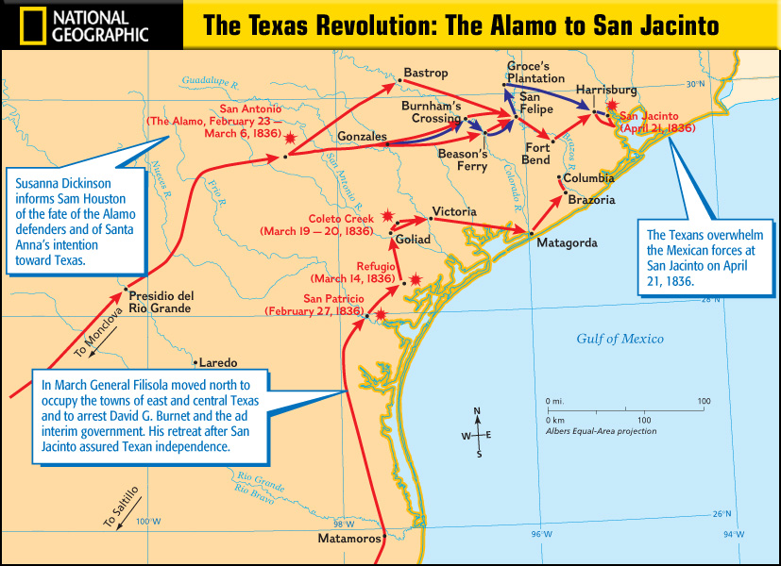

After the Alamo…
______________________________ and some Texans were in the town of Coleto Creek. Sam Houston ordered them to ______________ after the loss at the Alamo. But Fannin delayed…

The Runaway Scrape – March 7-20, 1836
After the massacres at the Alamo and Goliad,
Sam Houston ordered the Texas to ______________ east across Texas in a __________ ___________ pattern. Sam Houston was widely criticized for his decision in the Runaway Scrape. Some Texans thought of Houston as a coward while others supported him saying his strategy was genius.
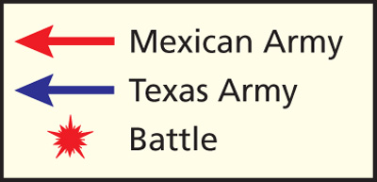

Massacre At Goliad - March 27, 1836
Mexican leader, General Urrea, surrounded Colonel James Fannin and the Texans at Coleto Creek. Realizing they are outnumbered, Texans ______________ at discretion. Urrea marched the Texans to the city of _______________ where Santa Anna ordered the Texans to be __________________ even though they surrendered. ________________________ Texans were shot at gunpoint with only a few escaping. ______________________________________ helped united the Texans like the Alamo.

Coward or Genius?

Directions: Read the following passages below. Then write 2 body paragraphs, one arguing that Sam Houston was a coward, the other arguing that Houston was a genius.

Each body paragraph should include:
- topic sentence
- citation for each source (ex. In document 2,…)
- 3 pieces of evidence (can be from multiple sources)
- Explanation and connection to topic sentence for each piece of evidence
- Conclusion sentence

Document 1
Sam Houston learned that Santa Anna was heading to Gonzales, where Houston had fewer than 400 men. With more than 700 Mexican troops advancing on them, the Texans were in danger. Houston ordered a retreat. Many civilians packed their belongings and left as well. Houston then ordered the town of Gonzales burned so that the Mexican troops would not take any additional supplies.

Document 2
Several Texas troops openly rebelled against Houston, criticizing him for retreating. Even President Burnet [President of Texas] challenged Houston to fight. “The enemy are laughing you to scorn [disdain, contempt, or disrespect].”

Document 3
With news of Goliad, some angry Texans began to demand an attack on Mexican forces. The Texas army had grown to more than 1,200 men after the fall of the Alamo. Houston, however believed that his army was still too small and untrained to defeat the larger and better –supplied Mexican army.

Document 4
As we passed through the streets of Gonzales, we noticed great lights in the houses and the people packing up their household effect in all possible haste. A man came out on the piazza [town square] and said (addressing the army), "In the name of God, gentlemen, I hope you are not going to leave the families behind!" Someone in our ranks answered [sarcastically], "O yes, we are all looking out for number one."

- Kuykendall’s, a Texan solider, account of the Runaway Scrape

Body Paragraph 1 – Sam Houston was a Coward

- Thesis or Topic Sentence:___________________________________________________________________
______________________________________________________________________________________________
- Source # _____ Evidence #1__________________________________________________________________
___________________________________________________________________________________________
Explanation _______________________________________________________________________________
Connection to Topic Sentence______________________________________________________________
- Source # _____ Evidence #2__________________________________________________________________
___________________________________________________________________________________________
Explanation _______________________________________________________________________________
Connection to Topic Sentence______________________________________________________________
- Source # _____ Evidence #3 __________________________________________________________________
___________________________________________________________________________________________
Explanation _______________________________________________________________________________
Connection to Topic Sentence______________________________________________________________
- Conclusion Sentence: _______________________________________________________________________
______________________________________________________________________________________________

Body Paragraph 2 – Sam Houston was a genius

- Thesis or Topic Sentence:___________________________________________________________________
______________________________________________________________________________________________
- Source # _____ Evidence #1__________________________________________________________________
___________________________________________________________________________________________
Explanation _______________________________________________________________________________
Connection to Topic Sentence______________________________________________________________
- Source # _____ Evidence #2__________________________________________________________________
___________________________________________________________________________________________
Explanation _______________________________________________________________________________
Connection to Topic Sentence______________________________________________________________
- Source # _____ Evidence #3 __________________________________________________________________
___________________________________________________________________________________________
Explanation _______________________________________________________________________________
Connection to Topic Sentence______________________________________________________________
- Conclusion Sentence: _______________________________________________________________________
______________________________________________________________________________________________

