Name ______________________________ Period ____________________
Date _______________________________ Texas History

Texas Revolution Compare and Contrast

Directions: In the columns below, write the DIFFERENCES and SIMILIARITIES between the Battle of the Alamo and the Battle of San Jacinto.
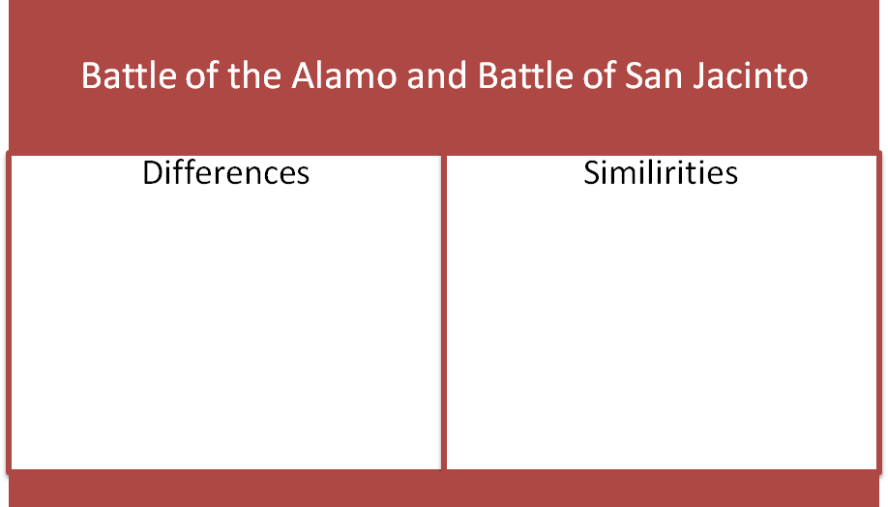
Directions: Write a paragraph comparing and contrasting the two battles.
________________________________________________________________________________________________________________________________________________________________________________________________________________________________________________________________________________________________________________________________________________________________________________________________________________________________________________________________________________________________________________________________________________________________________________________________________________________________________________________________________________________________________________________________________________________________________________________________________________________________________________________________________________________________________________________________________________________________________________________________________________________________________________________________________________________________________________________________________________________________________________________________________________________________________________________________________________________________________________________________________________________________________________________________________________________________________________________________________________________________________________________________________________________________________________________________________________________________________________________________________________________________________________________________________________________________________________________________________________________________________________________________________________________________________________________________________________________________________________________________________________________________________
Directions: Choose two individuals to compare and contrast that played a role in the Texas Revolution.
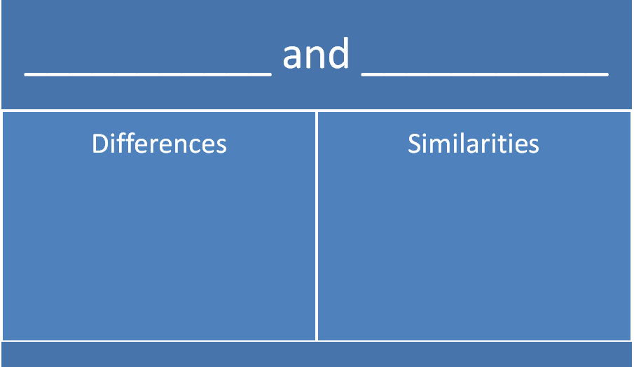
Directions: Write one paragraph comparing and contrasting the two individuals you selected.
__________________________________________________________________________________________________________________________________________________________________________________________________________________________________________________________________________________________________________________________________________________________________________________________________________________________________________________________________________________________________________________________________________________________________________________________________________________________________________________________________________________________________________________________________________________________________________________________________________________________________________________________________________________________________________________________________________________________________________________________________________________________________________________________________________________________________________________________________________________________________________________________________________________________________________________________________________________________________________________________________________________________________________________________________________________________________________________________________________________________________________________________________________________________________________________________________________________________________________________________________________________________________________________________________________________________________________________________________________________________________________________________________________________________________________________________________________________________________________________________________________________________________________________________________________________________________________________________________________________________________________________________________________________________________________________________________________________________________________________________________________________________________________________________________________________________________________________________________________________________________________________________________________________

