**The Texas Declaration of Independence**

**Grievance 3**

**COAHUILA**

**=**

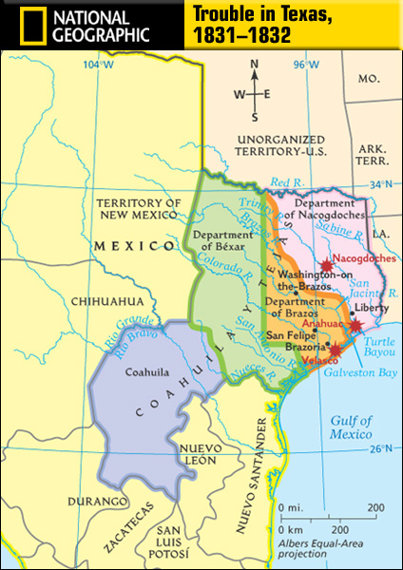

**TEJAS =**



**The Texas Declaration of Independence**

**Grievance 5**

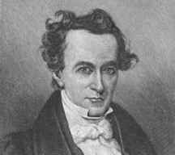

**The Texas Declaration of Independence**

**Grievance 7**



**The Texas Declaration of Independence**

**Grievance 9**

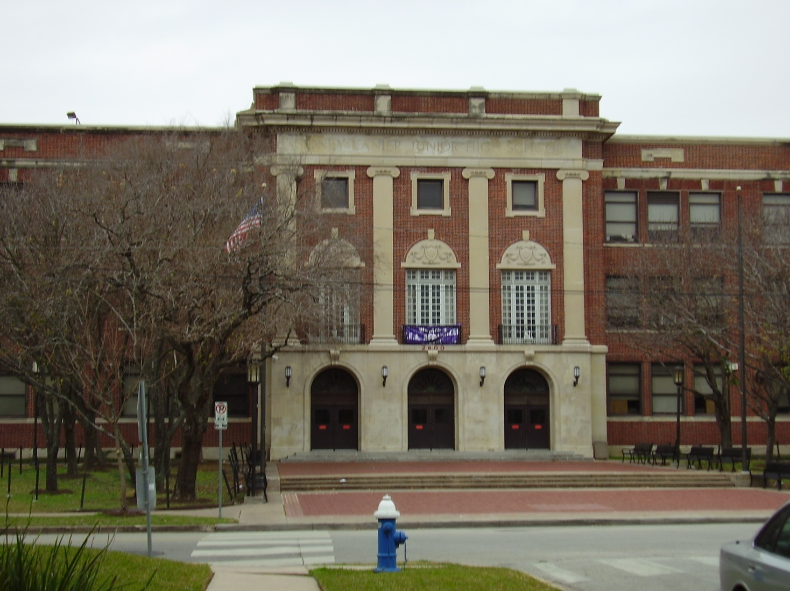

**The Texas Declaration of Independence**

**Grievance 11**

in



**=**



**The Texas Declaration of Independence**

**Grievance 13**

**Coahuila y Tejas’s**

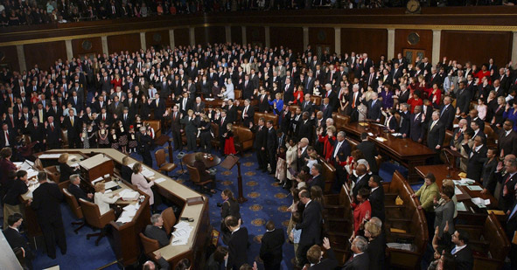

**The Texas Declaration of Independence**

**Grievance 1**



**The Texas Declaration of Independence**

**Grievance 2**

**Arrr, I will take that Aye.**

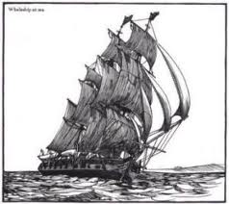

**The Texas Declaration of Independence**

**Grievance 4**



**The Texas Declaration of Independence**

**Grievance 6**

**Give me that! Now!**



**The Texas Declaration of Independence**

**Grievance 8**

**=**

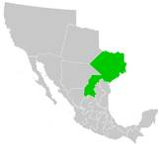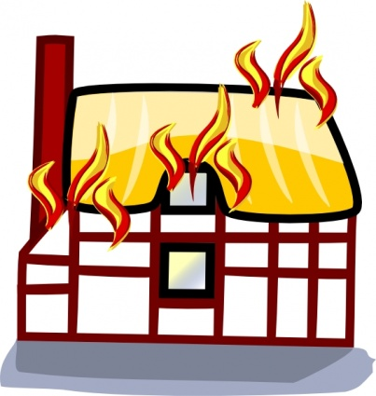

**The Texas Declaration of Independence**

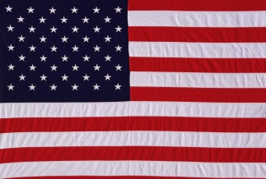

**Grievance 10**



**The Texas Declaration of Independence**

**Grievance 12**

**Revolution Revolution Revolution Revolution**  **Revolution**

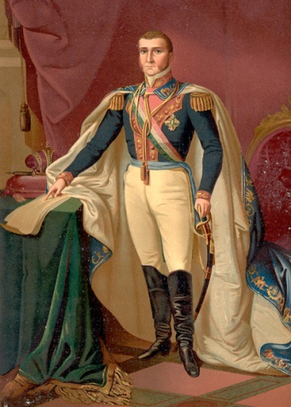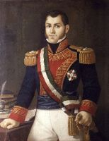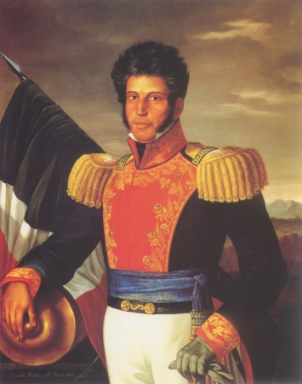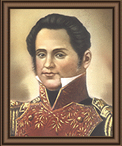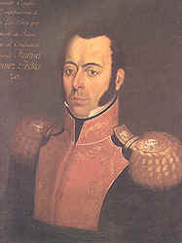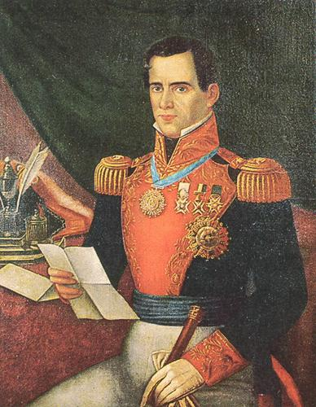

**SANTA ANNA**

Name:______________________ Date:________________

MYP/Vanguard Texas History Class Period:__________

**Texas Declaration of Independence: List of Grievances**



**Directions:**

**1) Look at the images from the grievances at your table.**

**2) Find the matching grievance from the original Texas Declaration of Independence.**

**3) Take the actual grievances and put them in your OWN WORDS on the matching number below.**

**4) At the end of each in parentheses tell me if it is a Political, Economic, Religious, or Social Issue.**

**1.) ______________________________________________________________________________**

**________________________________________________________________________________**

**2.) ______________________________________________________________________________**

**________________________________________________________________________________**

**3.) ______________________________________________________________________________**

**________________________________________________________________________________**

**4.) ______________________________________________________________________________**

**________________________________________________________________________________**

**5.) ______________________________________________________________________________**

**________________________________________________________________________________**

**6.) ______________________________________________________________________________**

**________________________________________________________________________________**

**7.) ______________________________________________________________________________**

**________________________________________________________________________________**

**8.) ______________________________________________________________________________**

**________________________________________________________________________________**

**9.) ______________________________________________________________________________**

**________________________________________________________________________________**

**10.) _____________________________________________________________________________**

**________________________________________________________________________________**

**11.) _____________________________________________________________________________**

**________________________________________________________________________________**

**12.) _____________________________________________________________________________**

**________________________________________________________________________________**

**13.) _____________________________________________________________________________**

**________________________________________________________________________________**