Name: _____________________ Class Period:_______
Texas History Date: ____________
Texas Revolution Story
Directions: Use the word bank to fill in the blanks in the following reading assignment.

The Beginning of the War
On ______________, 1835 the Texas Revolution began with the battle of ______________. The Mexican army was ordered to get a cannon back from the town and the Texans responded by putting up a flag that said _______________________________. The Texans continued to have success during the beginning of the war with victories in the areas of _______________ and _______________. These victories were good for the Texans but also caused them to become ______________.
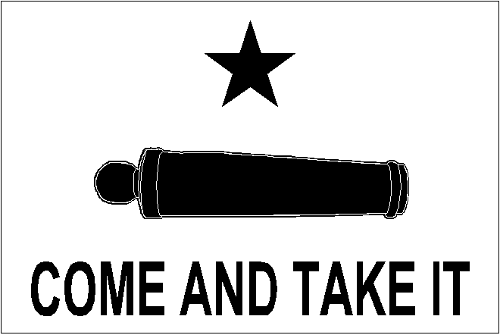
The Alamo and Goliad
The Texans early victories did not prepare them for what would happen the following year. A small group of men were stationed at the Alamo in _________________ to defend it from the ___________________ army. A lawyer from Anahuac named ____________________ was placed in charge of the regular army at the Alamo, while ___________________ was in charge of the volunteer army. Later the famous Tennessee senator and frontiersman _____________________ joined them. The Texans were taken by surprise when ____________________ and the Mexican army arrived in San Antonio early and the ____________ of the Alamo began. The constant ________________ lasted for ____ days. Unfortunately, the Texans were _______________ and on ______________, 1836 all of the men in the Alamo died. During the battle of the Alamo Sam Houston knew it was important to write a ___________________________________________ so the rest of the world would know why they wanted their freedom. Further south ___________________ was with more Texas troops near Goliad. He was forced to ________________________ to the Mexican army because he did not listen to Sam Houston. Even though the Texans thought they were safe Santa Anna ordered a ______________________, killing around 350 soldiers being held as prisoners.
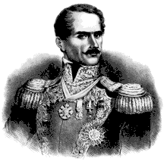
The End of the Revolution
After the Alamo and Goliad the Texans were very upset. However, instead of staying to fight Sam Houston ordered his men to ___________, zig-zaging away from Santa Anna to the east in what became known as the ______________________________. Santa Anna made a big mistake and ____________ his army while chasing down the Texans. Finally on _______________, 1836 Sam Houston decided it was the perfect time to attack the Mexicans who were in an open field now called _______________________________________. Sam Houston inspired his troops calling out “_________________________________!” The Texans _________________ the Mexicans and were able to defeat them in ____ minutes. Still upset about the Alamo and Goliad Texans demanded that Sam Houston ___________________ Santa Anna. Sam Houston refused and instead gave Santa Anna his life in return for him signing the ___________________________________. On _________________, 1836 this treaty gave Texans what they really wanted; not more death……..Independence!
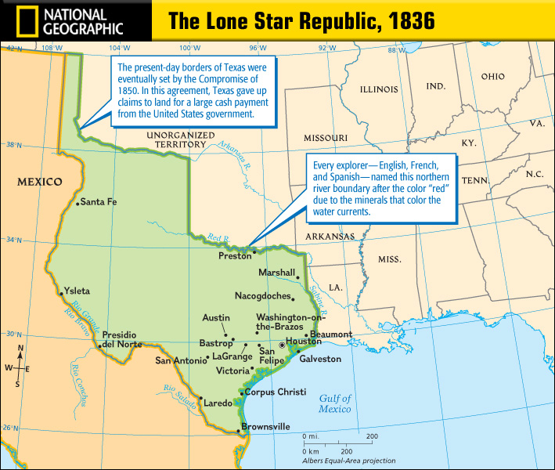
Word Bank:
The Beginning of the Revolution
Come and Take It October 2nd overconfident San Antonio Goliad Gonzales

The Alamo and Goliad
13 massacre Mexican San Antonio March 6 outnumbered
Declaration of Independence David Crockett surrender James Bowie siege
Santa Anna bombardment William Travis James Fannin
The End of the Revolution
Treaty of Velasco 18 retreat execute split surprised San Jacinto
Remember the Alamo Runaway Scrape April 21st May 14th

