Version A: Name: _____________________________________ Period: ______________

The Universe Quiz

A = TRUE
B = FALSE

- A light year is the time it takes light to travel around the universe.
- A giant cloud of gas and dust in the galaxy where stars are created is called a protostar.
- The Hubble Telescope is on Mt. Rainier in Washington state.
- Stars with less mass will last longer than stars with more mass.
- Most galaxies are moving away from one another, which means the universe is expanding.
- Scientists use spectrographs to determine what elements stars are made of.
- A star’s brightness as seen from earth is called its apparent magnitude.
- The amplitude of a wave is the distance from one wave crest to the next wave crest.
- Only scientists in the United States can use the Hubble Telescope.
- Massive stars may become neutron stars when they die.

Multiple Choice
Identify the letter of the choice that best completes the statement or answers the question.

- The electromagnetic spectrum shows the range of electromagnetic waves. Which waves have the longest wavelength?
a. visible light | c. radio waves | e. gamma waves
b. infrared waves | d. X-rays

- A supernova is the explosion of a dying
a. medium-sized star. |  | c. protostar. |  | e. None of the above
b. giant or supergiant star. |  | d. nebula.
- One piece of evidence that supports the big bang theory is the observation that most galaxies are moving
a. toward our galaxy. | c. in random. | e. None of the above
b. toward one another. | d. away from one another.

- A light-year is a unit of
a. time | c. mass | e. distance
b. speed | d. absolute magnitude

- A star is born when
  - helium atoms fusing together to make hydrogen release large amounts of energy.
  - helium atoms come apart into hydrogen atoms absorb large amounts of energy.
  - hydrogen atoms fusing together to make helium release large amounts of energy.
  - hydrogen atoms fusing with helium atoms release large amounts of energy.
  - None of the above.

- While gazing at the stars one night, you notice that one star is brighter than another. This is an example of
a. parallax | c. gravity | e. None of the above
b. apparent magnitude | d. absolute magnitude
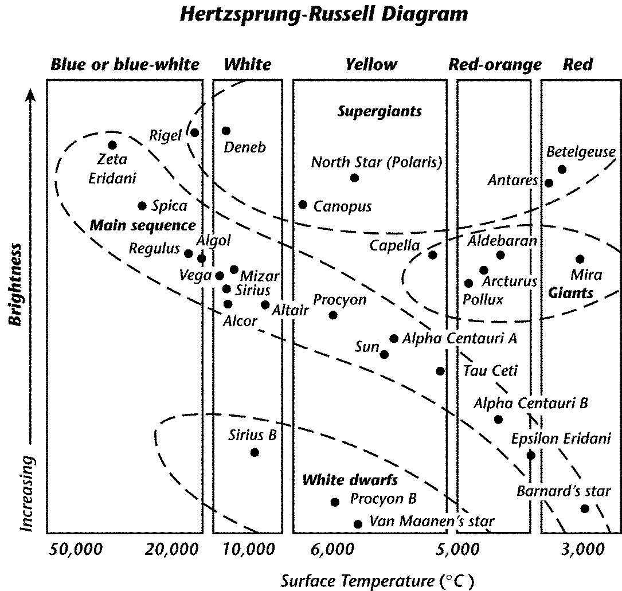
17. Which of the stars below is brighter than the sun?
a. Deneb d. Sirius B
b. Epsilon Eridani e. None of the above
c. Barnard’s Star

- Which star is hotter than Tau Ceti, but cooler than Altair?
a. North Star d. Deneb
b. Alpha Centauri B e. None of the above
c. Sirius B

- Which star is likely to be red?
a. Rigel d. Sirius B
b. Spica e. None of the above
c. Betelgeuse

- Compared to Rigel, Alpha Centauri A is
- cooler and brighter
- cooler and dimmer
- hotter and brighter
- hotter and dimmer
- none of the above

- The Hertzsprung-Russell diagram shows that main sequence stars
a. | are mostly hot and dim.
b. | are mostly cool and bright.
c. | increase in brightness as they increase in temperature.
d. | decrease in brightness as they increase in temperature.
e | None of the Above

Which word does not belong?

22. elliptical spiral universe irregular
A B C D

23. hotter red cooler Betelguese
A B C D

24. brightness age temperature size
A B C D

25. medium supergiant giant brightness
A B C D

26. Stars that are still burning hydrogen as their fuel are called
a. supergiants
b. neutrons stars
c. main sequence stars
d. quasars
e. None of the above

27.Most of the elements were created

  - when the Big Bang occurred.
  - when our solar system was created.
  - by nuclear fusion in stars.
  - by nebulas.
  - None of the above.

28.Our solar system belongs to which galaxy?
a. Andromeda | c. Betelgeuse | e. None of the above
b. Alpha Centauri | d. Milky Way

29.It takes light ___________ minutes to travel from the sun to the Earth.

  - 95 minutes
  - 8 minutes
  - 10 minutes
  - 30 minutes
  - None of the above

- ______________________ discovered that the galaxies are moving away from each other.

  - Spitzer
  - CERN
  - Hubble
  - Einstein
  - None of the above.

