Name:__________________________ Class Period:_______

**Westward Expansion Map**

**Directions**: Create a map of the different areas acquired by the United States during Westward Expansion. Make sure each area matches the color on your map key.

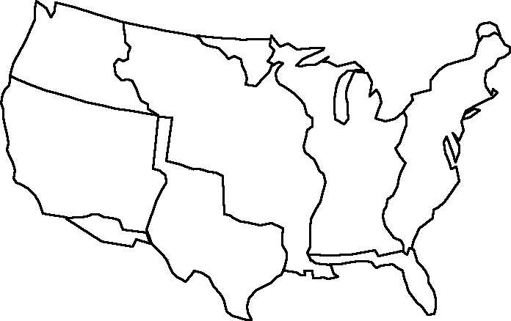

**Map Key:**

|  |  |  |  |  |  |
| --- | --- | --- | --- | --- | --- |
|  | Original 13 Colonies |  | British Cession |  | Oregon Country |
|  | Northwest Territories |  | Florida Cession |  | Mexican Cession |
|  | Louisiana Purchase |  | Texas Annexation |  | Gadsden Purchase |

|  |  |  |  |
| --- | --- | --- | --- |
| **Name of Territory** | **Date acquired (Year)** | **Who did we get it from?**  **(What country?)** | **How did we get it? (Treaty, purchase, annex, etc.)** |
| Original 13 Colonies |  |  |  |
| Northwest Territories |  |  |  |
| Louisiana Purchase |  |  |  |
| British Cession |  |  |  |
| Florida Cession |  |  |  |
| Texas Annexation |  |  |  |
| Oregon Country |  |  |  |
| Mexican Cession |  |  |  |
| Gadsden Purchase |  |  |  |

1) What is Manifest Destiny?

2) What were some of the ways that Americans acquired land as they expanded?

3) Was it fair for the United States to follow their belief of Manifest Destiny? Why or why not?

4) How would America be different without westward expansion? Explain.

**Original 13 Colonies**



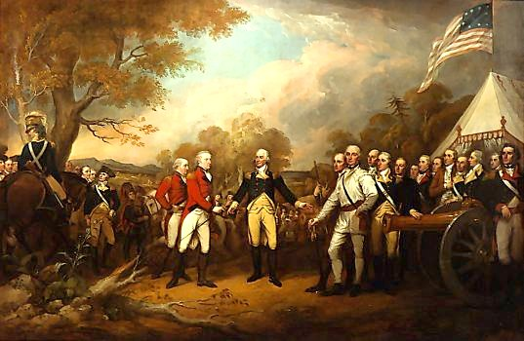

**The first Anglo settlers came to the east coast of what is now the United States from Great Britain in 1607. The land was already occupied by natives who had lived there for thousands of years. As more and more settlers came, the area grew to 13 colonies, all ruled by Great Britain. By 1775 the colonists were tired of paying taxes to Great Britain that did not help them at all. They declared their independence in 1776 and won the war, the American Revolution, in 1783. With the signing of the** [**Treaty of Paris**](http://en.wikipedia.org/wiki/Treaty_of_Paris_(1783)) **and** [**Treaties of Versailles**](http://en.wikipedia.org/wiki/Peace_of_Paris_(1783)) **the 13 colonies officially became the United States of America.**

**Northwest Territory**



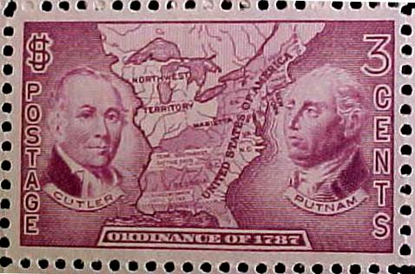

**The Northwest Territory was a vast area that was not officially claimed by anyone, with the exception of the Native Americans that already lived on the land. The Northwest Ordinance (a law or act by a government) was passed in 1789 officially claiming the territory so it could later be created into new states. This was important for 3 reasons;**

**1) It showed that Americans wanted to expand to the West**

**2) They wanted to create new states instead of expand the original 13**

**3) It banned slavery in the territory.**

**Louisiana Purchase**



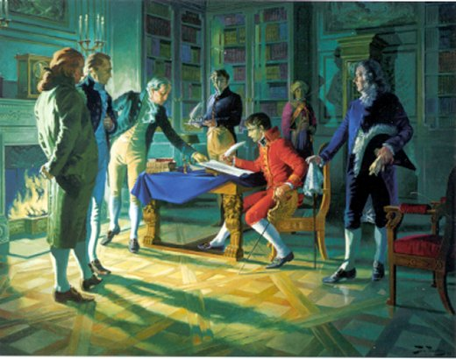

**This territory was owned (off and on) by France during the 1800s. During the end of this time period Napoleon came to control France. By 1803 he had very little interest in the Americas and was willing to sell the land to President Thomas Jefferson for a very cheap price. Jefferson purchased the land for 15 million dollars (that is only 3 cent an acre). This doubled the size of the United States and added many natural resources. The area was so big that they were not even sure what was out there so Jefferson hired Lewis and Clark to search the area with the help of Sacajawea.**

**British Cession**



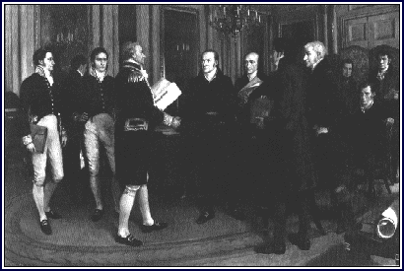

**By 1818 the United States had explored the Louisiana Purchase and was ready to create/draw the boundaries of their newly acquired land. One problem they had was Great Britain owned Canada at the time and a small piece of land that would make America’s borders uneven. In the Treaty of 1818 they settled these land disputes and officially turned over the land to the United States, while agreeing to jointly administer Oregon Country.**

**Florida Cession**



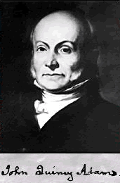

**For many years Spain had rejected any efforts by the Americans to purchase Florida. However, by 1819 Spain was dealing with a colonial revolution, the Mexican fight for independence, and was willing to start to negotiate. Under the orders of James Monroe, John Quincy Adams signed the Adams-Onis treaty which set new boundaries at Louisiana and Texas and sold Florida to the United States for 5 million dollars.**

**Texas Annexation**



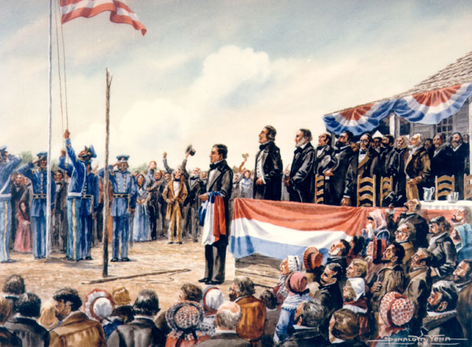

**Once Texas gained their independence from Mexico most Texans wanted to become a part of the United States. At first the United States was reluctant because Mexico did not recognize Texas as an independent country and still claimed them. By 1844 most Americans agreed that Texas should be annexed and with the help of President James Polk Texas was incorporated in 1845. This lead to the Mexican-American War.**

**Oregon Country**



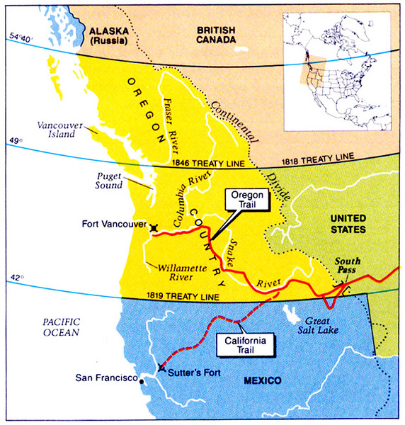

**Since British Cession in 1818 this territory had been jointly administered (ruled) by Great Britain and the United States. Both sides did not like having to share the area and it grew harder and harder for them to do so in a civil manner. In 1846 they negotiated a treaty that gave the land now known as Canada to Great Britain and left Oregon country to the United States.**

**Mexican Cession**



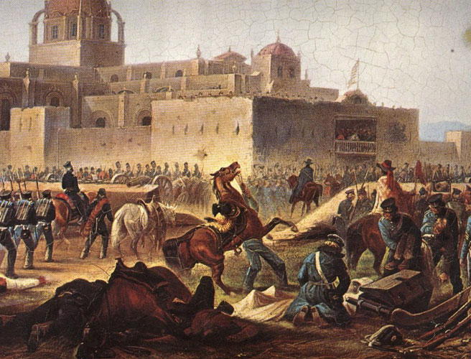

**As predicted once Texas was annexed by the United States, war broke out between Mexico and the United States. The war was known as the Mexican-American war and lasted for 2 years, although it did not take long for the United States to control most of the disputed land. In 1848 the Treaty of Guadalupe Hidalgo was signed and gave the United States most of the southwest. Mexico received 18.25 million dollars (half of what the United States offered before the war) and the United States officially became bicoastal.**

**Gadsden Purchase**



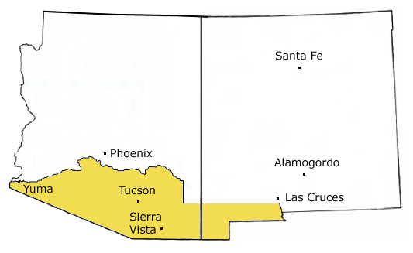

**The last purchase to complete what is now know as the continental United States (not including Hawaii and Alaska) was made in 1853. This northern portion of Mexico was purchased for 10 million dollars. It completed a railroad and to make the border between the United States and Mexico more even.**